Coffee Cake.

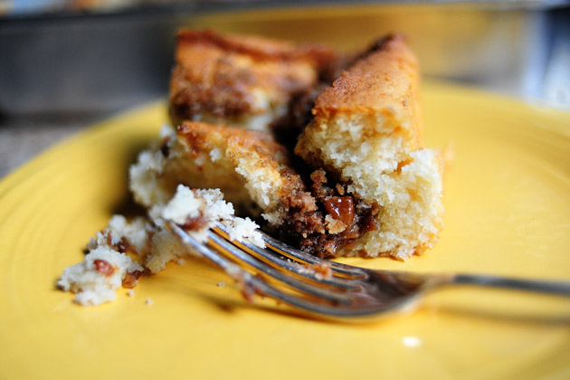

.

Ingredients

* FOR THE CAKE:
* 1-½ stick Butter, Softened
* 2 cups (scant) Sugar
* 3 cups Flour, Sifted
* 4 teaspoons Baking Powder
* 1 teaspoon Salt
* 1-¼ cup Whole Milk
* 2 Eggs, separated, with Whites, Beaten Until Stiff
* FOR THE TOPPING:
* 1-½ stick Butter, Softened
* ¾ cups Flour
* 1-½ cup Brown Sugar
* 2 Tablespoons Cinnamon
* 1-½ cup Pecans, Chopped

Preparation

Preheat oven to 350 degrees. Sift together flour, baking powder, and salt. Beat the 2 egg whites and set aside.

Cream butter and sugar, and add the one egg yolk. Add flour mixture and milk alternately until combined. Don’t overbeat. Fold in beaten egg whites with a rubber spatula. Spread in a well-greased 9 x 13 (or LARGER!) baking pan. A cake pan with higher sides would be best.

In a separate bowl, combine topping ingredients with a pastry cutter until crumbly. Sprinkle all over the top.

Bake for 40 to 45 minutes, or until no longer jiggly. Serve warm—delicious!